**Querying in Cosmos DB**

**SQL with Cosmos DB queries:**

## Sample document

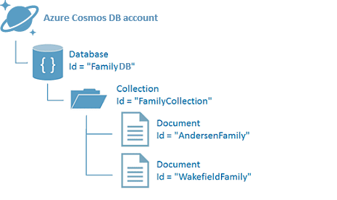

The SQL queries in this article use the following sample document.

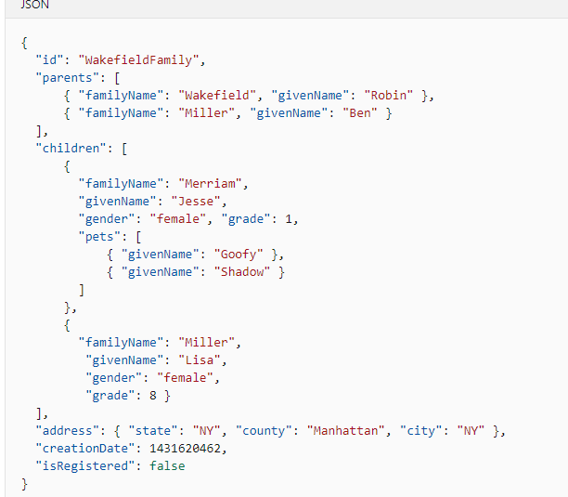

Inside the Cosmos DB , data is stored in the form of JSON format

## Example query 1

Given the sample family document above, following SQL query returns the documents where the id field matches WakefieldFamily. Since it's a SELECT * statement, the output of the query is the complete JSON document.

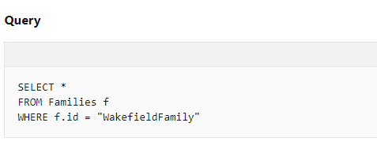

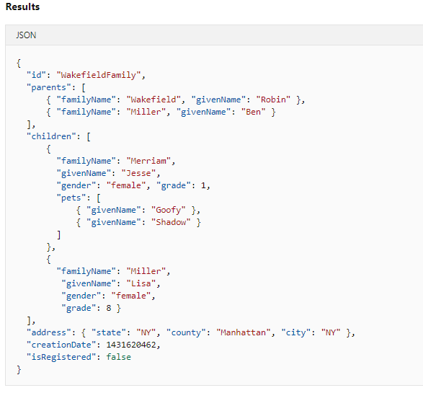

## Example query 2

The next query returns all the given names of children in the family whose id matches WakefieldFamily ordered by their grade.

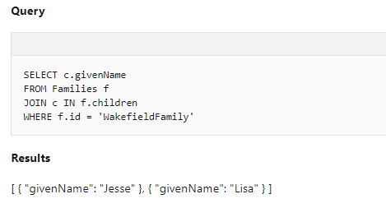

<https://www.red-gate.com/simple-talk/sql/nosql-databases/introduction-to-sql-for-cosmos-db/>

<https://cosmosdb.github.io/labs/dotnet/labs/03-querying_in_azure_cosmosdb.html>

**Custom queries with @Query Annotation using Mongo**

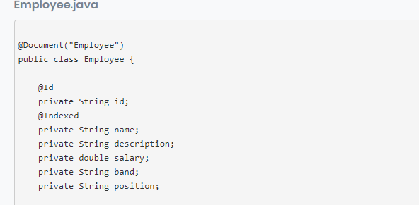

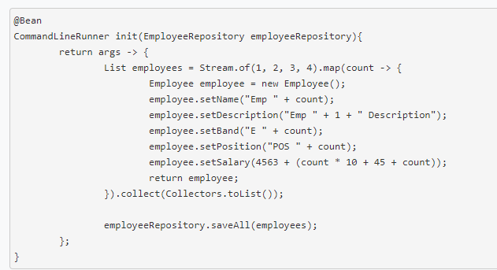

Entering the data into the Employee Document

**Sample queries:**

1. **To find an Employee by name**

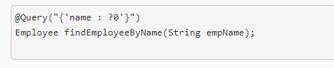

?0 substitutes the value from method arguments into the JSON query string

1. **Using filter option**

By default, all the properties of Employee document will be fetched. If we want to ignore some of the properties , we can use filter option.

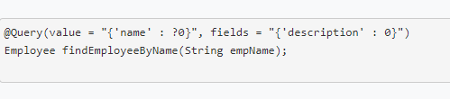

Here description is ignored.

1. **AND Operator**

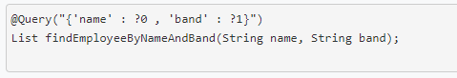

1. **Nested Queries:**

Suppose if we have multiple collections like Department and Employee Collections where

Each Department can have multiple Employees then

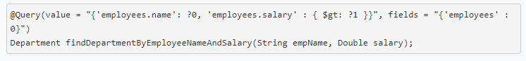

This returns Department Collection whose Employee name is empName and Salary is greater than salary passed.

1. **$lt and $gt**

Less than and Greater than

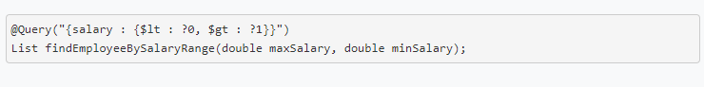

This returns salary greater than minSalary and less than maxSalary (comma,) is used for combining two queries.

1. **Sorting queries:**

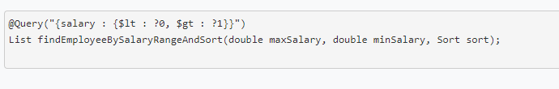

This returns Employees salary range and sort them based on salary

1. Regex using $regex

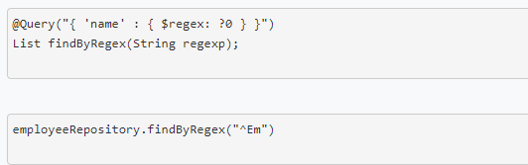

It is used to query regular expressions like the above example finds the name of the Employee whose name starts with “EM”

1. Other Examples

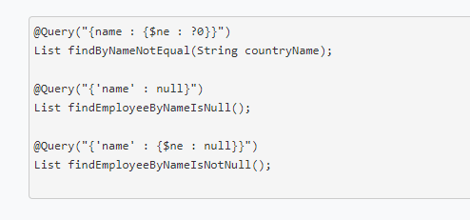

$ne represents not equal in the above example.